G&L Motion Control
PiCPro for Windows Application Note

Document Number: AN000053

Topic: Understanding and Organizing PiCPro Files

Scope
This Application Note applies to PiCPro for Windows for all hardware platforms.

Purpose

This Application Note provides information for both developers and end users on using PiCPro to organize and maintain files for an application. It applies generally to all processor types, but specifics may vary based on features available in a particular model.

Introduction

If you are coming from a PLC oriented background, one aspect of the G&L unit that you may find different is the many files that are involved on your PC. There may be several hundred files require to produce the ladder diagram that runs the machine. Most of these are the function or function block files that are used in the ladder diagram to create the logic program for the machine. The final program will likely only use a small percentage of these functions and so will not need all the files. But whether you are developing a program or using it to maintain a machine, in order to live happily with PiCPro, these files must be well organized and managed. PiCPro provides tools to assist with this, but the programmer or user have the responsibility to understand what is required and how to use the tools.

PiCPro is used to create a machine control program using ladder diagram or structured text format and instructions. These are saved in a file with an LDO extension. Prior to downloading to the MMC_SD, the program must be converted to a format that the MMC_SD CPU can understand. This is done by a process known as Compiling and it results in a file with the same name as the LDO but with a BIN extension. The compiled code running in the control cannot be reverse compiled back in to ladder format. In order to allow online monitoring or to make changes, it is essential to ensure that the ladder diagram version on the PC is identical to the compiled version in the control. This is done by giving both a date and time stamp at the time of compiling and downloading. If the two do not match, then PiCPro will not be able to monitor or make changes. Clearly this is another reason why good file management is required.

We’ll start by addressing the programming situation and then look at the options available for what is shipped to the end customer.

PiCPro Project Manager

PiCPro 11 was the first Windows version to use Project Manager. Its functionality has remained much the same through version 15.1, with additions to support new features such as the drive files for the analog and digital smart drives. The use of Project Manager and the standard G&L installation folders is optional, but highly recommended. If you don’t use them, you are much more susceptible to loss of files and the inability to maintain the application after a period of time. For these reasons, at some point, PiCPro may also be changed to require the use of Project Manager. So getting started with it as early as possible is recommended.

PiCPro Files

Figure 1 illustrates how a main application ladder diagram is built from functions and capabilities that come from different sources. These sources are broken in to several categories shown in rows across the diagram. Notice that in all rows, the column before the main ladder consists of Library files that will have a .LIB extension. These files are built by a program called a Compiler from the original source code in whatever computer language that they were written. They contain the executable code for the G&L CPU ready to be inserted and linked in the main ladder diagram. The left hand column shows the source code files. Keeping these categories in separate folders by origin will simplify maintenance and possible upgrading considerably. In particular, merging the standard libraries can make a PiCPro version upgrade a nightmare.

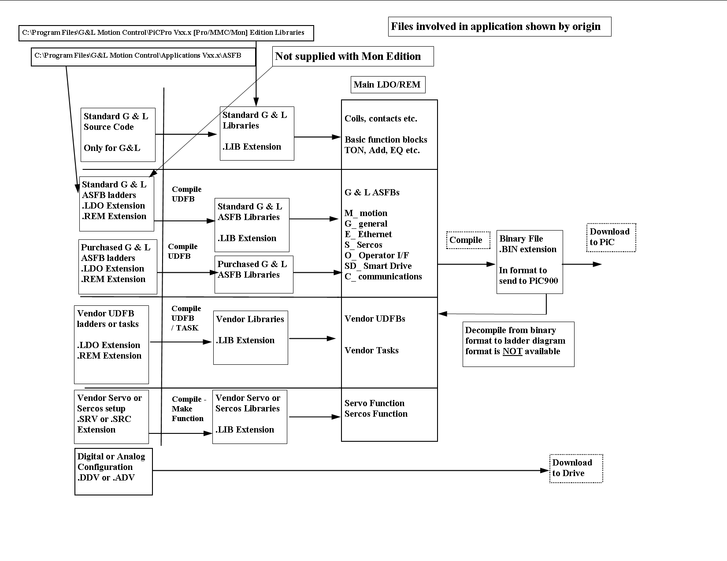
PiCPro Standard Libraries

The top row contains the standard G&L functions that come with all versions of PiCPro. These files are default installed in the folder

C:\Program Files\G&L Motion Control\PiCPro V15.1 [Professional] [MMC] [Monitor] Edition]\Libraries

The folder changes with the PiCPro version and Edition.

The source code for these is not provided and is not required for any PiCPro operation. New libraries are shipped with all new PiCPro versions and may also be included in any Service Packs that are posted on the G&L web site.

CPU and other smart modules such as Ethernet and Sercos as well as the MMC Smart Drives have their own resident programs known as firmware. Firmware is included as HEX files with all PiCPro versions and if changed will be included in Service Packs.

Always use the matching version of PiCPro, Libraries and Firmware.

Standard ASFB

The second row shows more G&L provided function blocks called Application Specific Function Blocks. They come with the MMC and Professional Editions of PiCPro on a second CD and install into the folder

C:\Program Files\G&L Motion Control\Applications V15.1.1\Asfb

These are not supplied with Monitor Edition. Monitor Edition is intended for end users to maintain and troubleshoot their equipment. If any are used, they must be included with the files for the machine by the programmer.
These differ from the first row in the source language used to create them. The source language here is PiCPro ladder diagram. Common requirements in an application have been programmed as ladder diagrams and then compiled in to function blocks in .LIB files. The function blocks can be used directly in the main ladder, giving faster programming and clearer, more compact diagrams. The functions are broken into groups which can be identified by the first letter.

E_ functions handle Ethernet capability
G_ functions are general purpose
M_ functions are for motion
OI_ are for Cimrex operator interfaces
OPC_ are for Ole for Process Control
SD_ are for Digital Smart Drives
S_ are for Sercos applications

The main ladder can be programmed and animated as long as the .LIB files are available. Along with the LIB files, G&L includes the source LDO (ladder diagram) and REM files (network comments) plus CHM (compiled help) files. This allows the user to see the logic behind the function outline in the main ladder if necessary and obtain on line help. In general, users should not be concerned about whether a function block is a standard function or an ASFB. They can be treated as black boxes that perform the functionality described in the on line help and there should be no need to look inside them at the ladder diagram code.

Having the LDO files allows the ASFB libraries to be rebuilt when changing to a newer version of PiCPro However, new ASFB versions are issued with each PiCPro release and you may want to consider using these instead as they may contain problem fixes a well as new features. The downside of this is that improvements to these may also result in changes to the function such as additional inputs and outputs. So you need to make sure of compatibility each time.

The revision level of these functions can be seen from the xx number of the EN input of an ASFB. A revision history is kept in the network 2 comments field of the ASFB LDO.

The E, G, M, O, SD and S ASFB are included at no additional charge with PiCPro MMC and Professional Editions.

There are other ASFB that are sold separately and typically start with C. They are communication blocks for interfacing among others, Modicon Modbus and Allen Bradley Data Highway (DF1) protocols. They should be kept in separate folders from the standard ASFB to avoid problems with updating later.

In general, it is better to stick with the default install folders. It is also better to stay with the installed libraries, because the Help files are linked to the libraries. Where customers have moved only the M_ functions they want to the machine folder and recompiled those into new libraries, the Help functions are no longer available. Also, the Help functions use Internet Explorer capability to view the files. IE does not like a # character in its path names and so Help files will not be accessible if your folder name has a # character in it.

UDFB and Tasks

UDFB are User Defined Function Blocks. The difference between them and ASFB is that G&L wrote and provided the ASFB while UDFB are written by OEMs, integrators or end users. That is, they are written in ladder diagram and compiled in to Function Block libraries for use in the main application ladder. Help files can be created for these by the programmer, but often are not. Where vendors want to protect details of the function blocks, they may supply only the LIB files but not the LDO and REM files. This prevents the end user from viewing the ladder diagram behind the function. Often the blocks are so complex that this is not important. The difficulty it causes end users is that the libraries cannot be updated without the LDO files when upgrading versions of PiCPro. In this situation, the OEM needs to provide updated libraries to allow the upgrade to be done. The situation can be resolved by the use of the Lock File feature available in PiCPro 14 and later. Locking the UDFB LDO file against opening with a password prevents viewing and editing of it, but does not stop it from being compiled. So password locked UDFB ladders can be shipped to customers and can be version updated while still protecting the logic in the block.

Tasks are high priority functions written in ladder diagram. From the file maintenance point of view, they are no different than UDFB. They are written in ladder diagram and compiled to task libraries for use in the ladder.

The folder structure used for these is entirely up to the user. In some cases, the user may want to separate by them machine type or by function and so have more than one folder.

Servo and Sercos Setup Files

Servo setup files specify information about the servo axes used in the application. They have a .SRV extension and are specific to a machine. They also must be compiled into a LIB file for use in the ladder. Sercos files are obviously used only in Sercos applications and specify communications between the controller and drive. They are also compiled into libraries for use by the ladder.

Digital Drive Files

These differ from the files listed so far in that they are sent to the Digital Drives and not to the CPU running the ladder diagram. They also do not have a LIB file involved. They can be created offline and downloaded to the drives or created online and uploaded from the drives. Either way they are important for their record of drive settings should a similar machine be built or a drive need to be replaced on an existing machine.

Organizing a Development Project

There are many ways to organize files and projects. The following approach should cover most situations, but can be modified to suit particular requirements.

All projects use the standard PiCPro libraries. Some projects may use just the standard ASFBs. Others may use one of the purchased communications packages, or require UDFBs that they create.

All projects will have a main ladder diagram and servo setup file. While developing the program, it is recommended that you separate the files in folders according to the earlier diagram. That is

PiCPro Libraries in their standard install folder
Standard ASFBs in their standard install folder
Purchased ASFBs in their standard install folder(s)
Main ladder, servo setup file and library and DDV file in their machine specific folder
UDFBs and tasks as a sub folder of the machine or machine type folder

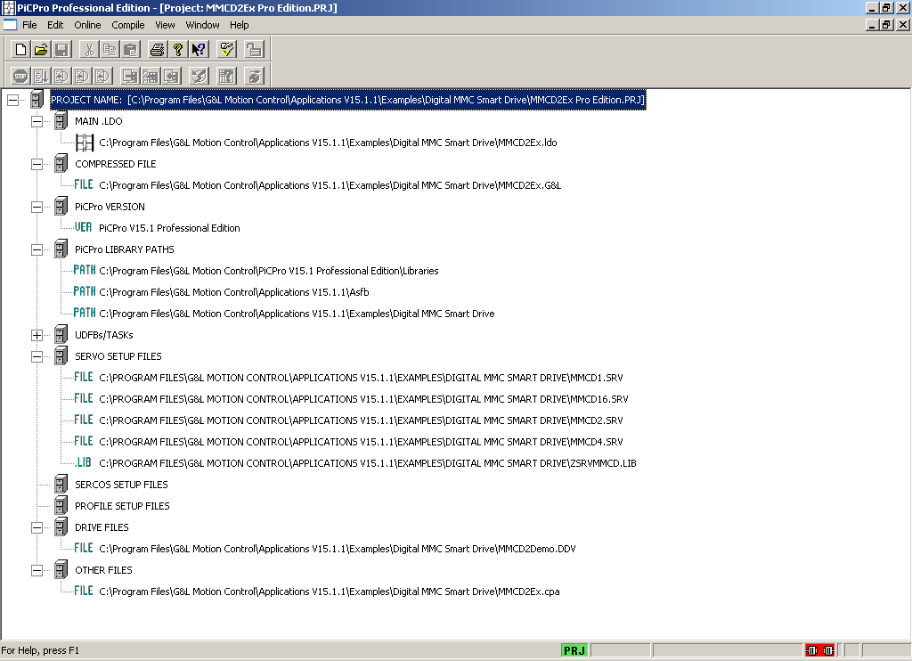

This is the project window for one of the Digital Smart Drive Applications Examples that come with PiCPro. We can see that the file that is open has a PRJ extension. This file should not be confused with the compressed project file that has a G&L extension. The PRJ file is simply a list of the folders and files used in the project. The G&L compressed file is the one that can be created to contain all the files used. The PRJ file is specific to a drive and folder structure and to a PiCPro Edition and Version. If a project is to be transferred to another PC, then either the drive and folder structure has to be identical or a new PRJ file is required.

Also, if development is done on PiCPro Professional Edition and the end user has the MMC Edition, then the PRJ file has to change. These topics will be further addressed later.

Under PiCPro Library Paths we can see that there are 3 folders used. The first two are the standard libraries and ASFB. The third is the machine specific folder. We can also see that the Main LDO, the Compressed G&L file and the servo setup files and libraries are kept in this folder. Notice that there are 4 servo SRV files and only 1 SRV library. This practice can be useful where there are different configurations of a standard machine with different axes arrangements. However, it can also be confusing to an end user who may not be certain which particular SRV file he has on his equipment. So in general, it is better to have one servo setup in one library.

The UDFB branch is not expanded in the diagram as it would be too large to fit in the picture. There is a separate branch for Sercos files if that type is used. Profile Setup Files were an earlier way to generate cam type motion and are no longer used on new applications. Other Files is a place to specify items such as operator screen files that are not specifically PiCPro files, but are required by the equipment. They must be added manually. In the PRJ file, they are for information only but if present, they will be added to the compressed G&L file also.

Starting a New Project

Every ladder diagram requires a certain amount of basic logic to do servo initialization, status and error detection, loop closure and so on. Ladder that contain this common code for different MMC_SD_D axes counts are provided in the folder

C:\Program Files\G&L Motion Control\Applications V15.1.1\Examples\Digital MMC Smart Drive

There are other folders and examples in this same area for different processor types and different functions. PiCPro can have several ladder diagrams open at one time so networks containing the functionality required can be copied from one ladder and pasted into another. Using these examples speeds up the process and gets proven logic for the basic functionality into your application. You may think that starting from scratch and programming everything is the best way to learn what is needed. We have found by experience that you will learn the basic logic by using it to debug your application. It is time consuming, error prone and counterproductive to try to do everything yourself.

In the initial stages when learning what is available in these examples, you should open the PRJ file from PiCPro. There is a Save As capability for a project, but it is better not to use it and to follow the following process instead.

We’ll assume that the project needs Modbus TCP, which is an additional purchased ASFB package from G&L Motion Control and will have some UDFBs that will be common to the type of machine being produced. So we will eventually need folders for the standard libraries, standard ASFBs, the Modbus TCP folder, the shared UDFB folder and the specific machine folder. However, we’ll start with just the basic 2 folders.
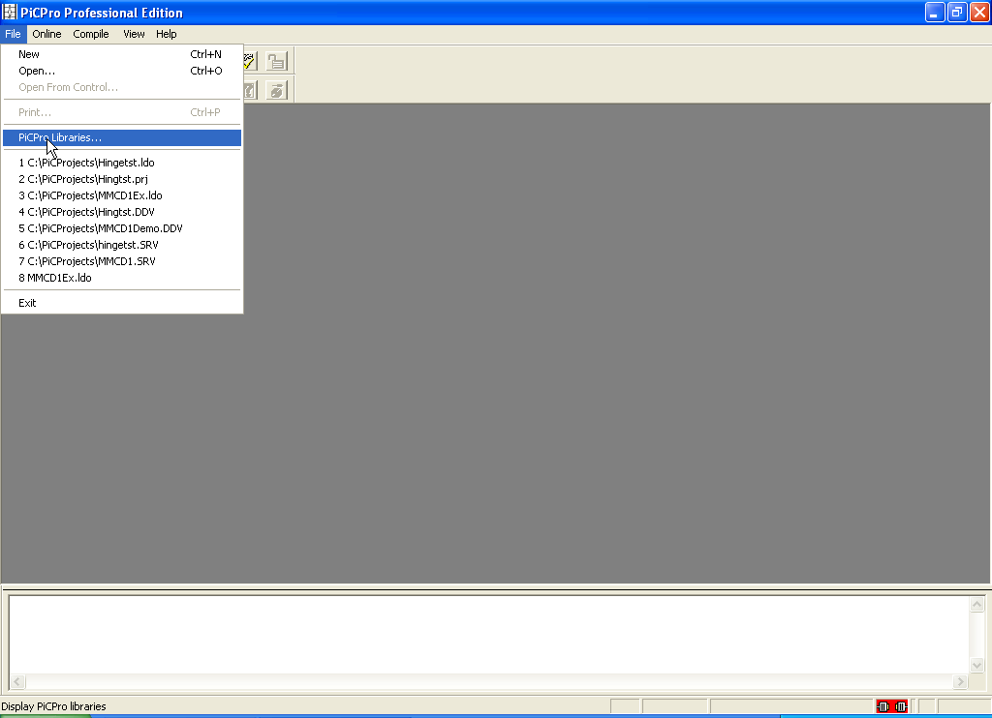
To set up these folders, choose File – PiCPro Libraries from the PiCPro menus.
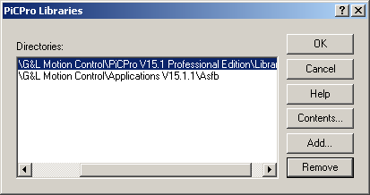

Use the Remove button to delete any folders that might show from a previous project that aren’t needed for this one.

Then use the Add button to build the list shown in the picture.

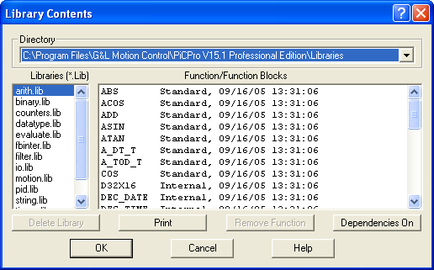
As a side issue, choosing the Contents button with the highlight bar on the Standard Libraries folder will show the library files and their contents.

This process can be repeated for each folder in the libraries list to see what functions are available.

We’ll start by creating a folder structure for the project. The example will assume a Widget machine line that has some UDFBs and that the particular machine is serial number W76-23. So we have the following

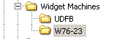

As discussed previously, it will be faster and less error prone to use the closest example ladder from the Applications folder. We’ll use the 2 axis example.

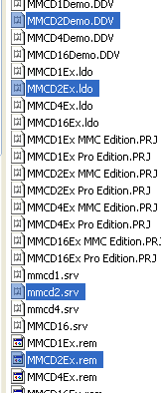
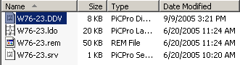

Copy the highlighted files from the left picture to your machine folder and rename them as shown in the above picture. Notice that the LIB file is not being copied. The only LIB file in a typical machine folder is for the servo setup and it is easily created using PiCPro.

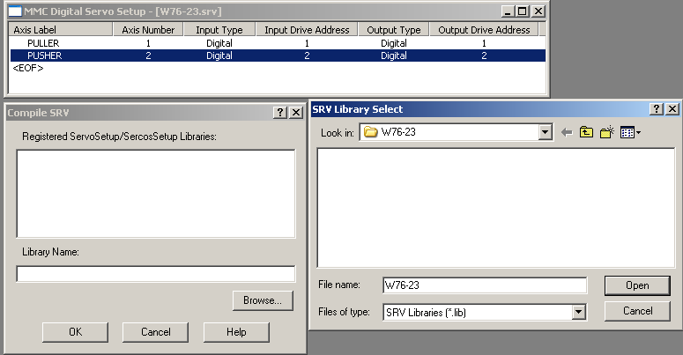
Open the SRV file and choose Compile Make Function from the pull down menu. Select the machine folder. There will be no libraries there so you will have to enter a name. The choice of library name is up to you. It will contain a servo function with the same name as the SRV file for use in the ladder.

We are now at the point where we can open the renamed ladder diagram using the File Open menu selection. This will be the result.

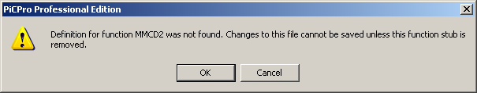
It is because PiCPro can’t find the servo function specified in the original ladder. Select OK.

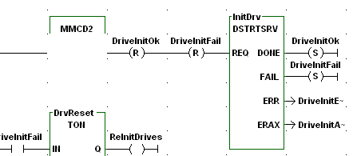

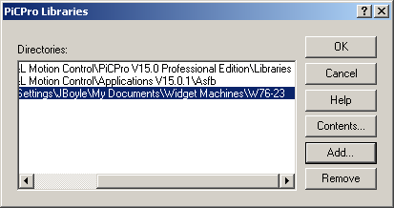
In order to have access to the new servo function, the machine folder needs to be added to the libraries path as shown.

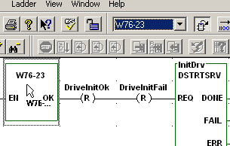

Then select the W76-23 function from the pick list
and drop it in the ladder with the Drop Function tool button. Save the ladder and move on to creating the project file.

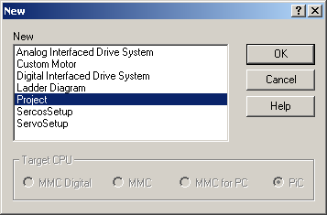
Select File New and then Project and PiCPro will build the project tree.
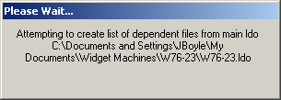

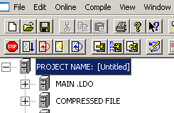
The project needs to be named and saved in the machine folder.

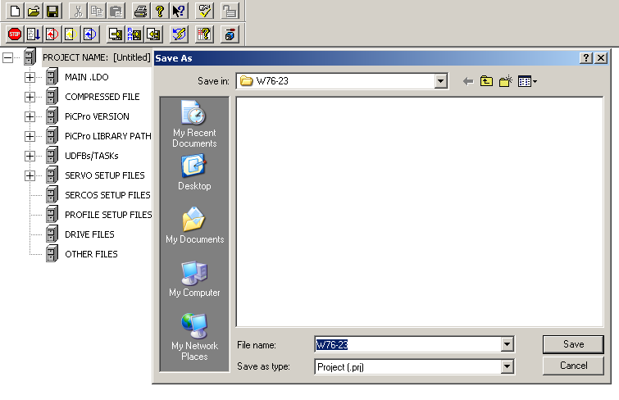
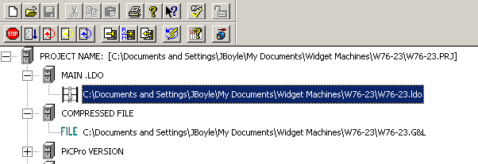
From now on, when starting a PiCPro session, open the project (.prj) file. In the PiCPro Open dialog window, selecting Files of Type Project will also present the choice of G&L file. Do not confuse the two. The PRJ file is a data base of the folders and files the project uses. It is specific to a folder structure and will only work with that folder structure. The G&L file will be explained later.

So now you should edit the ladder to perform the functions of the machine itself. When you come to the point where you want to introduce UDFBs that you create, they should be put in the UDFB folder. The files here will have extensions LDO, REM and LIB. You will need to add the UDFB folder to the Libraries list and then do an Update Project Tree.

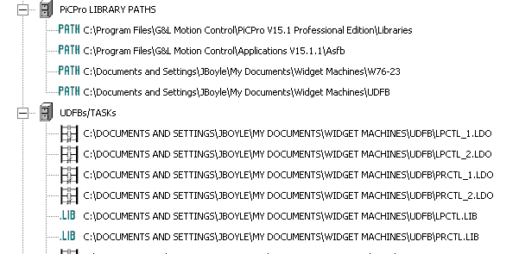
The additional library path and the UDFBs available can now be seen in the tree. Note the Lib files and the LDO files that the functions came from are shown. Project Manager always starts with the libraries and looks at the functions that are in them. It then adds the LDO file with the same name as the function to the tree. If the LDO cannot be found, it will flag the file with a red circle to show this. The main ladder can be opened as long as the LIB is available. However, you will not be able to look inside the function block at the ladder logic it performs and you will not be able to update the library in order to change to a different version of PiCPro.

The servo setup files are handled automatically by PiCPro and are placed in the Servo Setup branch when building the project tree and they can be seen in the next diagram. The Drive and Other Files branches need to be populated manually.

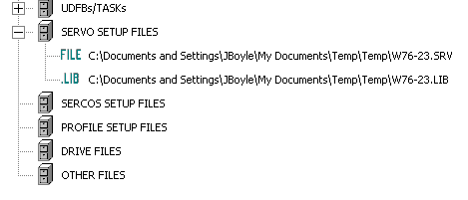
To add the drive file (ADV(s) or DDV), right click on the Drive Files header, click Add and then browse for the appropriate file and click Open.
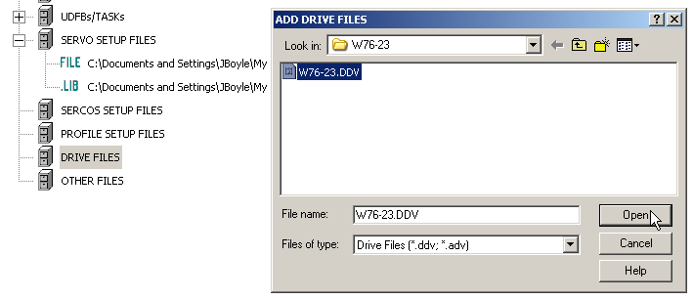
Do the same for any other files associated with the equipment such as CPA for Cimrex and OID for the ladder global variable link file.

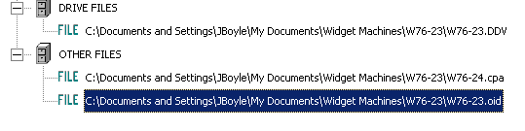
These files will then be stored in the G&L compressed file when it is created. When going online with the drive, it is best to double click the DDV file here in the project tree. This opens the offline file for the drive and any changes made and saved will be put in this file. Note this does not mean that the G&L file is updated. You will be prompted to compress the project again if changes are detected while the project is open.
Releasing the Project to Customers

Once the ladder is completed and finally tested on the machine, some decisions need to be made about what files will be shipped to customers. In general, it is best for most customers to have the fewest number of files organized in the simplest manner. The single best way to do this is by using the compressed G&L file mechanism. This file can be stored on the flash memory of the MMC-SD so that it is always with the equipment and can be uploaded to a PC from there. It can also be stored on the PC hard drive. The main concern with storing it on the MMC-SD is that flash memory read and write is a time consuming process. PiCPro V16 will significantly improve the time over earlier versions but it will still be a concern. Reducing the size of the G&L file by eliminating any unused functions and libraries is one way to help the time situation. Right click on the project name in the project window and select Properties.
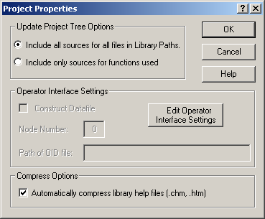
The default radio button selection will include all libraries and all source and help files (LDO, REM and CHM) for all functions found in the library paths.
The alternate selection will include only the source files for any functions that are used. The functions themselves are part of the libraries and will still be included.
In the example project, the G&L file size is 1.4MB with all included and 219KB with only used files included. This translates to 15% of the time taken to upload or download the smaller file compared to the larger file to flash disk.

We’ll return to other considerations in making this choice later. For now, we have a compressed G&L file that contains many files as well as a memory of the folder structure and drive that was used on the development PC. This folder structure may not be what the customer wants to use and in addition, it is usually better to put all the files into one folder for an end user.

Using PiCPro to open the G&L file presents us with some choices.

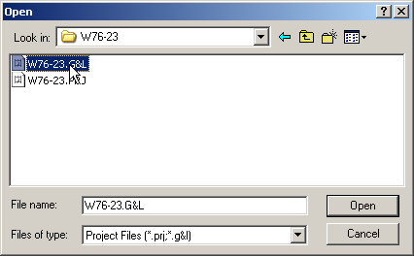
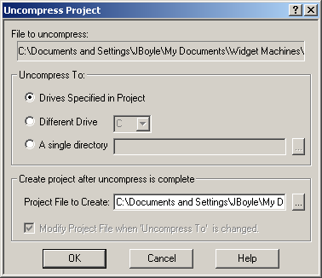
The default choice is Drives Specified in Project, but this is rarely the best one to use. The Different Drive selection is also uncommon. This leaves the Single Directory choice. As a developer, you may want to do that and uncompress to a Release folder on your system so you have a record of what was shipped.
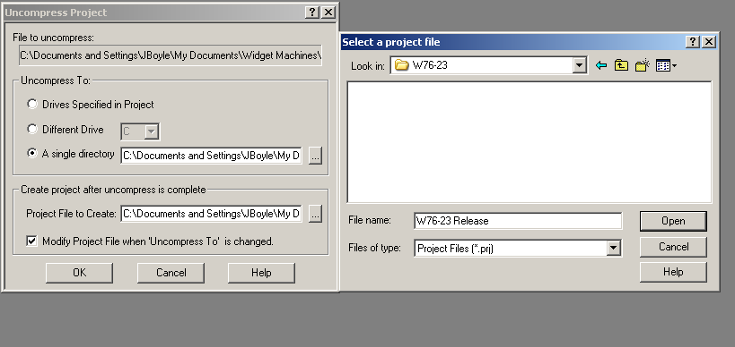
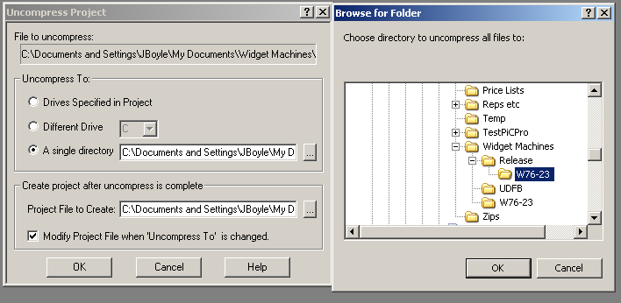

The above pictures show a single directory selection to a machine release folder and a new prj file name being specified in that folder.

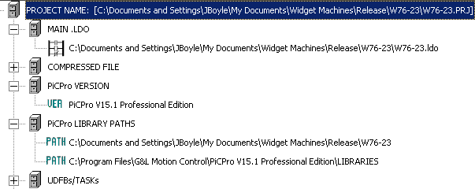

The project tree shows a couple of very important points about the PiCPro version and standard libraries. Uncompress remembers the version and edition of PiCPro that the project was developed under. Also, the standard libraries are not included in the G&L file. Remember that there are 3 editions of PiCPro. They are Professional, MMC and Monitor. Each installs in a different folder. So if the end customer is to use a different edition, then the project file needs modified.

Let’s assume that we need to convert to MMC edition for this customer.
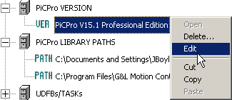
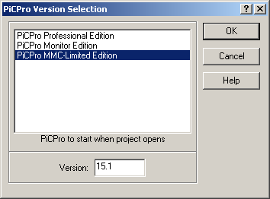
Right click on the current version and select edit then choose the appropriate edition.

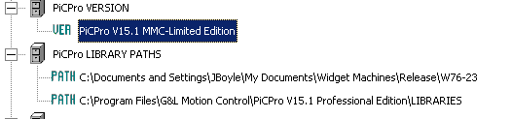
Note this does not change the standard library path. This needs to be done separately.

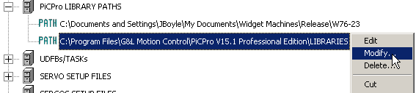

This can be done by right clicking on the current entry, selecting modify, deleting the current entry and adding the correct one in the Libraries dialog window that appears.

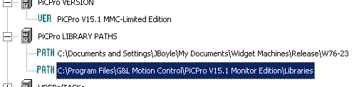
Now we have completed the conversion and can save the new project and go on to compressing it.

This will result in a G&L file that can be sent to the customer and also downloaded to the MMC_SD flash memory.

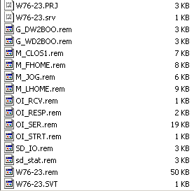
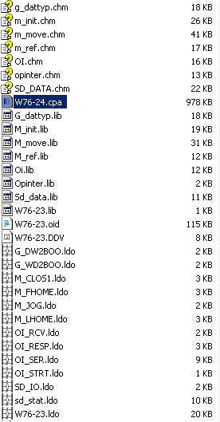

We can see that only the libraries with a function that is used in the project are included. For example, there are no E_ or S_ files shown. Also, only the LDO and REM files for the
functions used from these libraries are included. The matching CHM help files are present for the included libraries. The benefits of this are fewer files and smaller G&L file size. Fewer files mean less confusion for customers. Smaller G&L file size means less time to download the project to the flash disk. The save time for the 219K of this project to flash disk on and MMC_SD D16 card was 5 minutes with PiCPro version 15.1 and 1.5 minutes with PiCPro version 16.0. The 1.4 MB ‘all files included’ G&L file time would then be 30 minutes and 9 minutes respectively. The drawbacks of including only the used files come in to play if changes need to be made or if a PiCPro version upgrade is required. For example, looking at the Explorer pictures above, we can see that only 1 of the 7 possible G_ libraries and 3 of the 11 possible M_ libraries are included. In the 1 included G library, G_DATTYP there are 10 functions, but only 2 of the LDO files are shown. So changes at the customer using the released files would be limited as to what functions could be added. Partial library updates are possible when changing PiCPro version but there will be prompts to update missing functions every time PiCPro is started.

Module File Extensions

The following lists the file extensions used by PiCPro and explains their use.

ADV - The Analog Interfaced Drive File contains drive parameters and the associated motor parameters for an analog interfaced drive. It is saved from the MMC Analog Smart Drive setup. It can also be used to load a new drive.

BAK – The Backup copy of a LIB library file – the version created with the last Compile UDFB, Task or Servo Function. It can generally be deleted from the PC drive.

BIN - Binary format. A compiled (PiC /MMC language) ladder file is created when doing a FULL compile and download. Patching does NOT create a BIN file. A BIN cannot be converted back into uncompiled state for animating, etc. A BIN file can be uploaded from a PiC or MMC using the User Program – Backup – Application Program. It can be restored to the processor using User Program – Restore – Application Program. A BIN file can also be made from RAMDISK using User Program – Backup – RAMDISK. It will contain all files currently on the RAMDISK and can be used to restore it from User Program – Restore – RAMDISK

DDV - The Digital Interfaced Drive File contains drive parameters and the associated motor parameters for a digital interfaced drive. It is saved from the MMC Digital Smart Drive setup. It can also be used to load a new drive.

DPL - Dependency List is a list of all files the currently loaded module depends upon. It can be created from View – Build Dependency List. It provides the same information as Project Manager tree.

FRC - Forcing List of variables that can be forced and their values. It will be saved if any forced variables are designated and will be brought back the next time Forcing is selected.

G&L – Compressed project file containing in all files specified in Project Manager. It can be saved on a PC or flash disk in the PiC or MMC. It can be opened directly by PiCPro.

HEX – Hexadecimal format used for firmware. A ladder file made with Hex compile can be transferred to flash memory and will be loaded into operating memory on power up. This helps avoid loss of operating program from CMOS due to low battery level.

HTM - HTML Help file created to explain functionality of UDFBs using Edit Function Block Help

LBK - Backup copy of the ladder file – the version previous to the one created with the last save. Can generally be deleted, although may be used to revert to a previous program before edits by renaming to an LDO extension using Windows Explorer.

LDO - Ladder Diagram Object file contains the network logic for the main ladder or for ASFB, UDFB and Tasks. These are associated to REM files that contain network comments.

LIB – Library contains functions/function blocks to be used in the ladder. Created by Make (Servo) function or Compile UDFB/Task

LST – List Print file containing ladder, REM and cross reference, formatted for printing.

MAP – MAP Produces a readable symbol map file during compile when Generate Symbol Map is checked in Compile Settings. Has little value to end users.

OID - Operator Interface Definition is used to support the operator interface or Ethernet module. It is made during ladder compile when Construct Data File is checked in Compile Settings

PPR - PiCPro Restore Used to restore program to the control Save to File is chosen in the PiC Restore dialog

PRJ – Project contains a project generated from Project Manager. This file contains only a list of settings, folders and files in the project and not the files themselves. It is specific to the PiCPro Edition and Version that were used to create it.

RBK - Remarks backup is the version of the REM file before a Save was done. It can generally be deleted but if reverting to a previous version of ladder by renaming an LBK to LDO, then this file should be renamed to REM. LDO and REM files are linked and not keeping versions together can cause comments to appear in the wrong networks.

REM – Remarks file contains the comments for all networks in a module.

RTD - Real Time Display is a list of variables in the View Variables List. It is saved if it has any entries and will be restored the next time the View List is opened.

SCP - Scope Template contains the control panel and oscilloscope settings. It is created by Save Scope Template and can then be opened and used again to quickly set up the drive scope.

SCT - SERCOS View / Tune is the viewing and tuning data for the SERCOS axes used in application

SRC – SERCOS contains the setup data for SERCOS axes used in application

SRV - Servo Setup contains the data for all servo and digitizing axes used in application

SVT - Servo View / Tune is the viewing and tuning data for the servo axes used in application

TXT - Trace Text contains the captured oscilloscope trace data. Can be read back in to oscilloscope or a spreadsheet

UCP – Universal Communications Personality is used by the configuration tool when downloading the personality file to the Device Net scanner. It is created from the G&L Device Net Configuration Tool

UCT – Universal Communications Text is used by PiCPro when downloading your ladder
It is created from the G&L Device Net Configuration Tool

